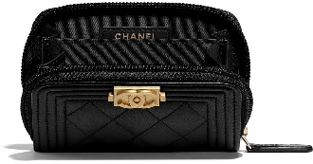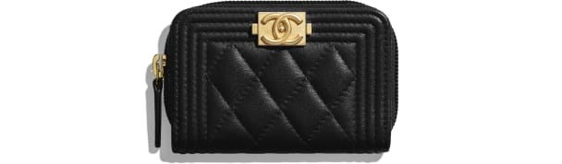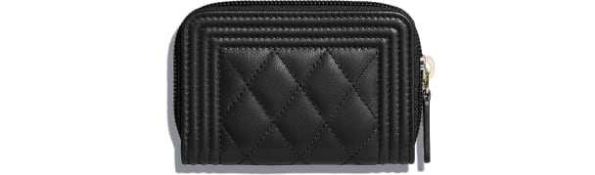

CHANEL-BOY CHANEL Zipped Coin Purse

SGD 800

COLOR :GREEN/BLACK  
SIZE : ONE SIZE  
IN STOCK

[Detail](file:///D:\\Final\\chanel_1w\\CHANEL.html" \l "collapse)

Lambskin & Gold-Tone Metal

• Reference: A80602 Y07659 94305

• 7.5 × 11 × 2 cm

[CARE & COMPOSITION](file:///D:\Final\chanel_1w\CHANEL.html#collapse1)

• Leather

• Imported